**CHAPTER-1: EXECUTIVE SUMMARY**

Java Full Stack Development encompasses a comprehensive approach to software development, allowing developers to work on both the frontend (client-side) and backend (server-side) of applications. A Java Full Stack developer is skilled in using Java and its associated technologies to create robust, scalable, and responsive web applications. This role involves expertise in various tools, frameworks, and technologies that span the entire application life cycle.

A [Java](https://www.geeksforgeeks.org/java/) Full Stack Developer is a professional who can write code and create applications using Java, a popular programming language. Any application consists of three layers: frontend or the face of the application, backend or the primary processing and logical part of the application and the database layer or the layer where all the data about the users and application is stored and fetched by various layers. As a part of being a professional Java Full Stack developer, the programmer should be able to code all the layers efficiently.

**Frontend Technologies:** HTML, CSS, JavaScript, and frameworks such as Angular, React, or Vue.js for responsive user interfaces.

**Backend Technologies:** Core Java, Spring Framework (Spring Boot, Spring MVC) for building REST APIs, and Hibernate for data management.

**Database Management:** Proficiency in relational databases (My SQL, Post greSQL) and familiarity with No SQL databases (MongoDB).

**Version Control and Collaboration:** Git for version control and platforms like GitHub, GitLab, or Bit bucket for collaborative development.

**Development Tools:** Integrated Development Environments (IDEs) like IntelliJ IDEA, Eclipse, and tools like Maven or Gradle for project management.

**Testing and Deployment:** Knowledge of testing tools (JUnit, Mockito) and experience with deployment platforms (Docker, Kubernetes, AWS or Azure).

**CHAPTER 2: INTRODUCTION**

A “Java full stack” refers to a type of software development technique that involves using the Java programming language for both the front-end and back-end parts of a web application. In easy-to understand terms, it means that Java is used to create both the parts of a website that you see and interact with (like buttons and forms) and the parts that work behind the scenes to store data, process requests, and make the website function properly.

Java Full Stack Development is an ideal pathway for developers seeking a holistic approach to software engineering. By mastering the entire tech stack, Java Full Stack developers are well-equipped to meet the demands of modern, dynamic web applications, driving innovation and adding value to organizations across industries.

**2.1: Introduction to Object-oriented Programming**

**1. Class:**

A class is a user-defined data type. It consists of data members and member functions, which can be accessed and used by creating an instance of that class. It represents the set of properties or methods that are common to all objects of one type. A class is like a blueprint for an object.

**2.Object:**

It is a basic unit of Object-Oriented Programming and represents the real-life entities. An Object is an instance of a Class. When a class is defined, no memory is allocated but when it is instantiated (i.e. an object is created) memory is allocated. An object has an identity, state, and behaviour. Each object contains data and code to manipulate the data. Objects can interact without having to know details of each other’s data or code, it is sufficient to know the type of message accepted and type of response returned by the objects.

**3. Encapsulation:**

Encapsulation is defined as the wrapping up of data under a single unit. It is the mechanism that binds together code and the data it manipulates. In Encapsulation, the variables or data of a class are hidden from any other class and can be accessed only through any member function of their class which they are declared.

**4. Inheritance:**

Inheritance is an important pillar of OOP (Object-Oriented Programming). The capability of a class to derive properties and characteristics from another class is called Inheritance. When we write a class, we inherit properties from other classes. So when we create a class, we do not need to write all the properties and functions again and again, as these can be inherited from another class that possesses it. Inheritance allows the user to reuse the code whenever possible and reduce its redundancy.

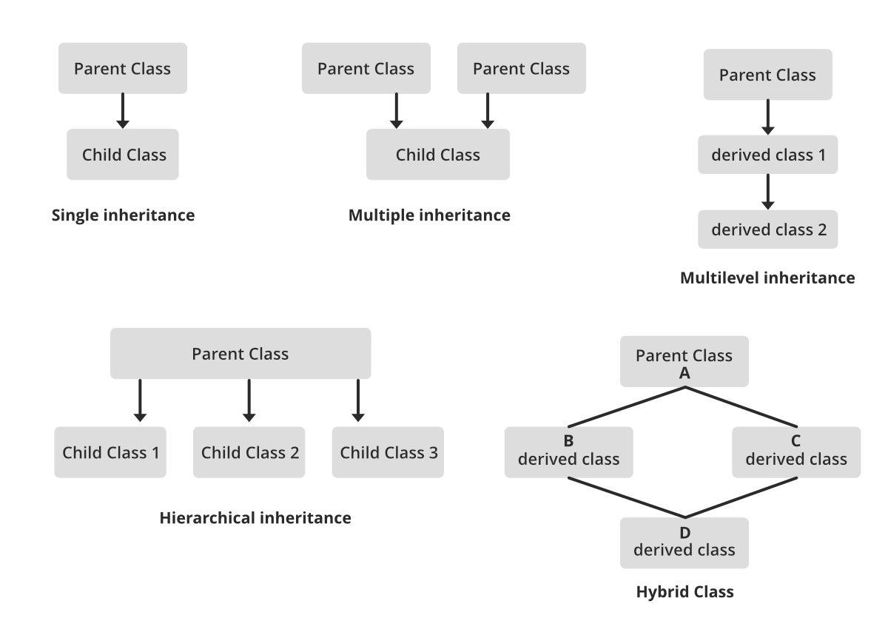

**Fig-1:** Inheritance

**5. Polymorphism:**

The word polymorphism means having many forms. In simple words, we can define polymorphism as the ability of a message to be displayed in more than one form. For example, A person at the same time can have different characteristics. Like a man at the same time is a father, a husband, an employee. So the same person possess different behaviour in different situations. This is called polymorphism.

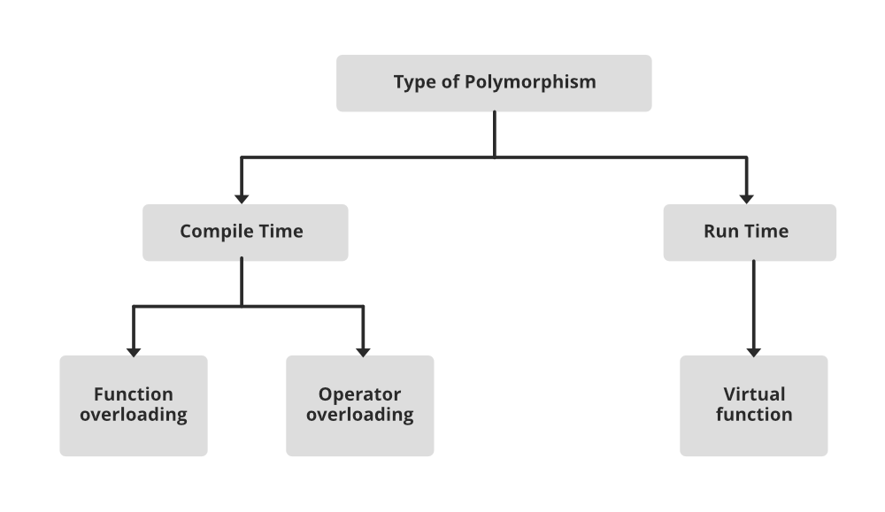

**Fig-2:** Polymorphism

**2.2: Git and GitHub GIT:**

Git is a version control system that intelligently tracks changes in files. Git is particularly useful when you and a group of people are all making changes to the same files at the same time. Typically, to do this in a Git-based workflow, you would:

• Create a branch off from the main copy of files that you (and your collaborators) are working on.

• Make edits to the files independently and safely on your own personal branch.

• Let Git intelligently merge your specific changes back into the main copy of files, so that your changes don't impact other people's updates.

• Let Git keep track of your and other people's changes, so you all stay working on the most up-to date version of the project.

**GITHUB:** GitHub is a cloud-based platform where you can store, share, and work together with others to write code. Storing your code in a "repository" on GitHub allows you to: • Showcase or share your work. • Track and manage changes to your code over time. • Let others review your code, and make suggestions to improve it. • Collaborate on a shared project, without worrying that your changes will impact the work of your collaborators before you're ready to integrate them. Collaborative working, one of GitHub’s fundamental features, is made possible by the open-source software, Git, upon which GitHub is built.

**2.3: Spring Boot**

Spring Boot is an open-source Java framework used to create a Micro Service. Spring boot is developed by Pivotal Team, and it provides a faster way to set up and an easier, configure, and run both simple and web-based applications. It is a combination of Spring Framework and Embedded Servers. The main goal of Spring Boot is to reduce development, unit test, and integration test time and in Spring Boot, there is no requirement for XML configuration.

**Pre-requisite of Spring Boot**

• Understanding of Java syntax and core concepts such as classes, objects, inheritance, interfaces, and exception handling

• Basic understanding of the Spring framework

• Knowledge of Web Technologies

**•** Familiarity with build tools such as Maven or Gradle

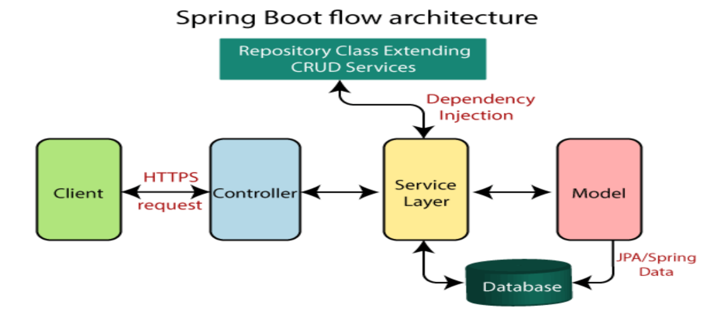

**Fig-3:** Spring Boot Flow Architecture

**2.4: Microservices**

* Microservices break complex applications into smaller, independent services that work together, enhancing scalability, and maintenance. Below is how microservices work:
* Applications are divided into self-contained services, each focused on a specific function, simplifying development and maintenance**.**
* Each microservice handles a particular business feature, like user authentication or product management, allowing for specialized development.
* Services interact via APIs, facilitating standardized information exchange and integration**.**
* Different technologies can be used for each service, enabling teams to select the best tools for their needs.
* Microservices can be updated independently, reducing risks during changes and enhancing system resilience.

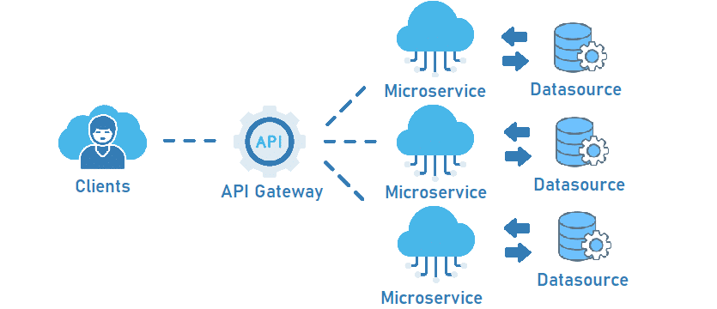

**Fig-4:** Microservices Flow Architecture

**2.5: React JS**

React is a JavaScript Library used to build user interfaces. It is developed by Facebook. It simplifies creating dynamic and interactive web apps with the help of component-based architecture, reusability, and efficient rendering with the JSX and virtual DOM.

React JS is used to create single-page applications (SPAs). It is known for its component-based architecture which allows you to create reusable UI components, making complex web applications easier to manage and maintain.

Before embarking on your React journey, ensure you have a suitable development environment set up. Here’s a roadmap to get you started:

1. Node.js and npm: Download and install Node.js (https://nodejs.org/en/download/package-manager/current) as it provides the runtime environment for JavaScript code execution. npm (Node Package Manager) is bundled with Node.js and is used to manage project dependencies.

2. Create React App (CRA): Using Create React App (CRA) to establish a new React project with minimal configuration. Run npx create-react-app my-react-app in your terminal, replacing my-react-app with your desired project name.

3. React Prerequisites: Before learning “React” you must have the knowledge of the following.

* HTML, CSS, & JavaScript

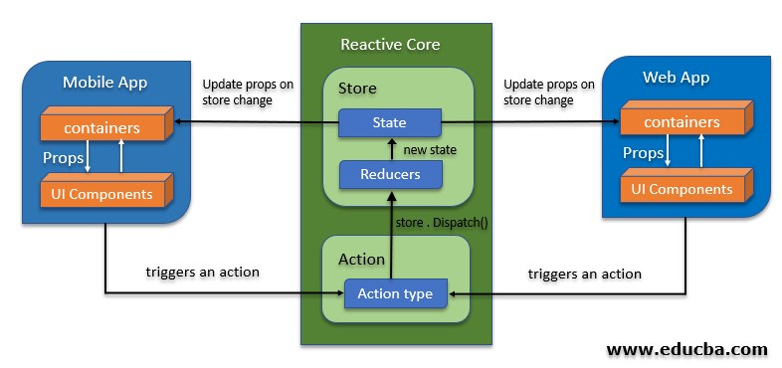**Fig-5:** React Application Architecture

**2.6: System Pre – Requisites:-**

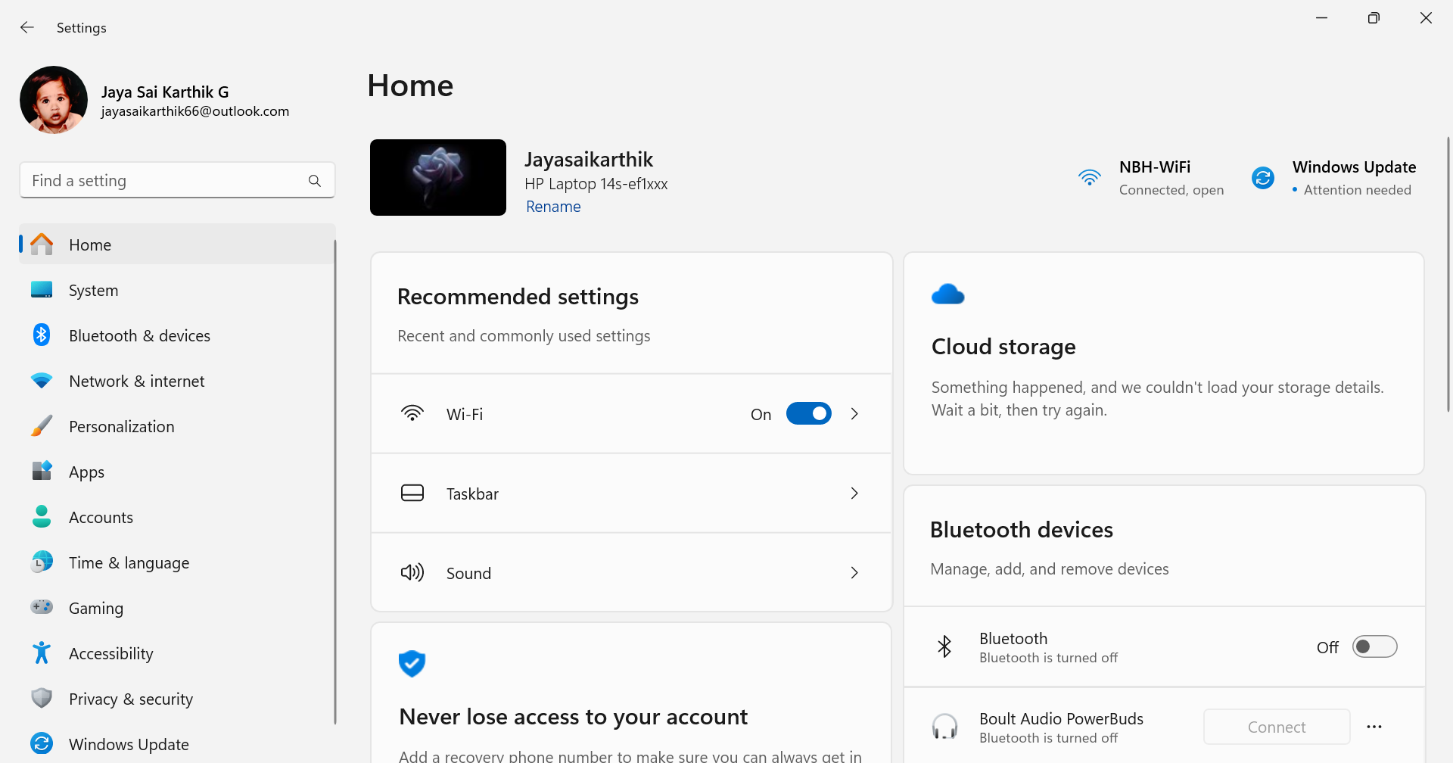**Device Name:** Jayasaikarthik

**Fig – 6:** About Laptop

**We have Used The Apps Like VS Code To Edit the Code In HTML..**

Visual Studio Code (VS Code) is a popular, free, and open-source code editor developed by Microsoft. It supports various programming languages and has features like syntax highlighting, intelligent code completion, debugging, and Git integration. VS Code is highly customizable, allowing users to add extensions for languages, themes, and tools to enhance functionality. With a user-friendly interface and fast performance, it’s widely used by developers for both simple and complex coding projects. Additionally, it supports cross-platform usage, available on Windows, macOS, and Linux, making it versatile for developers across different operating systems.

* **Extensibility**:
* Thousands of extensions available in the VS Code Marketplace.
* Support for languages like Python, JavaScript, C++, Java, and more.
* Framework-specific extensions like Angular, React, and Vue.js.
* **Intelligent Code Editing:**
* Syntax highlighting and IntelliSense for smart code completions.
* 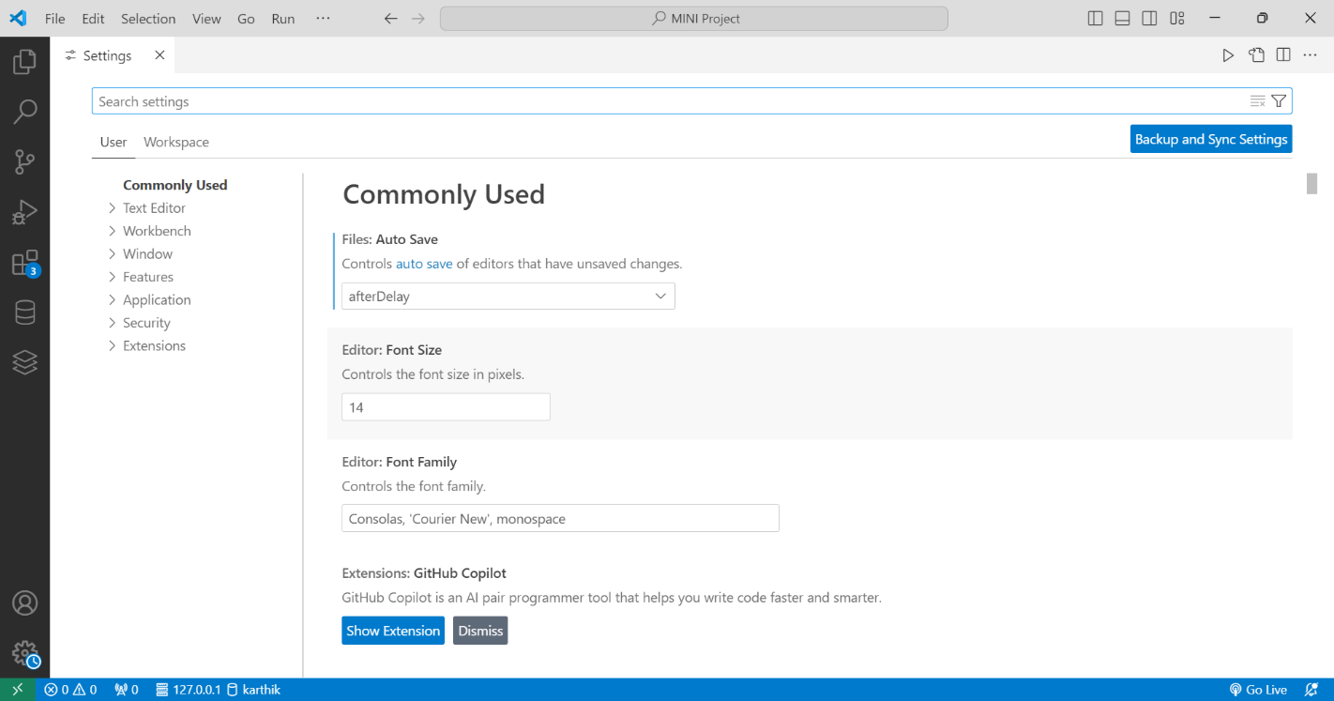Built-in debugging tools for multiple languages.

**Fig – 7:** About VS Code

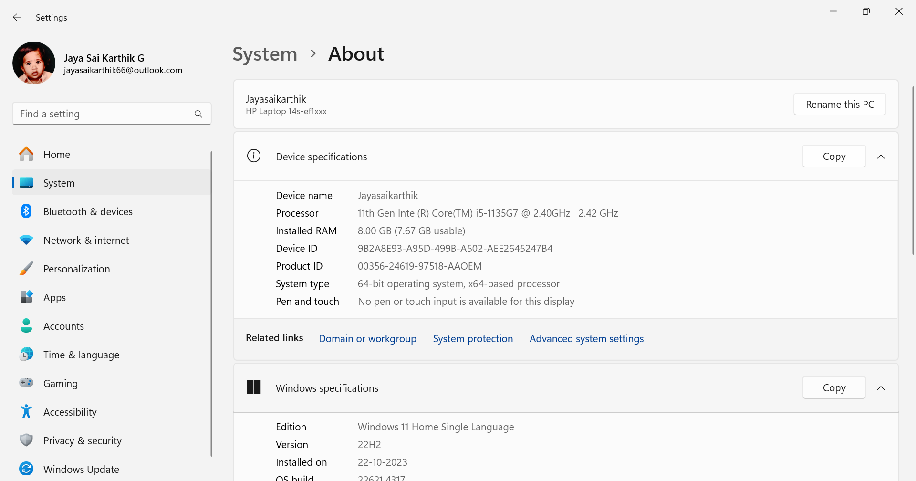**Device And Storage of the Laptop:**

**Fig – 8:** About Storage

**CHAPTER 3: OVERVIEW OF THE ORGANIZATION**

**About RESHAPP**

**Details about RESHAPP**

Name: RESHAPP Software Solutions Pvt.Ltd, Hyderabad (RSSPL).

**Overview:**

RESHAPP Software Solutions Private Limited (RSSPL) is indeed a newly formed private limited Indian non-government company, registered on April 6, 2024, and based in Hyderabad, Telangana. Given that it is only seven months old, RSSPL is likely in its initial stages, focusing on building its foundations and operations.

RSSPL is likely focused on providing technology-based services, potentially specializing in software development, IT consulting, and digital transformation solutions. Its location in Hyderabad, a major tech hub in India, positions it strategically for growth in the software and IT industry. Since it is only a few months old, RSSPL is likely in its foundational phase, setting up core business operations, developing a market presence, and building a client base. Initial activities might include business strategy development, talent acquisition, service line establishment, and industry networking.

**Mission:**

* **Client-centric excellence**

Our mission is to deliver client-centric excellence in every aspect of our IT solution services

* **Driving technological advancements**

As on IT solution services company, our mission be at the forefront of technological advance men

* **Enabling seamless progress**

Provide exceptional services that enable businesses to progress seamlessly in the digital realm.

**CHAPTER 4: MINI-PROJECT PART** Below are the main components and features that are commonly found in such websites:

**Key Aspects**

**4.1: User Accounts and Profiles**

* Account Creation: Users can sign up using email, social media, or Google accounts.
* Profile Customization: Users can create a profile with a photo, bio, social links, etc.

### 4.2: [Abstract](https://www.geeksforgeeks.org/types-of-artificial-intelligence/) and Objectives

At SELA Pharma Company, we are committed to enhancing health and well-being through our extensive range of pharmaceutical products. Our platform offers innovative solutions backed by rigorous research and development, ensuring the highest quality and safety standards. Explore our diverse portfolio of medications, supplements, and healthcare products designed to meet the needs of patients and healthcare providers alike. Join us in our mission to make healthcare accessible and effective for all.

In my Pharma Products website, your comprehensive resource for the latest pharmaceutical innovations and essential healthcare solutions. Our user-friendly interface is designed to streamline your experience, allowing you to easily browse and access detailed information about our extensive range of products. With intuitive navigation, advanced search functionalities, and up-to-date resources, we aim to support healthcare professionals, patients, and researchers in finding the right products to meet their needs efficiently and effectively.

**Abstract:**

Welcome to our comprehensive platform dedicated to the pharmaceutical industry. Our website serves as a hub for healthcare professionals, researchers, and consumers, offering a wide range of high-quality pharmaceutical products, including prescription medications, over-the-counter drugs, and specialty treatments. We prioritize transparency, providing detailed product information, safety guidelines, and clinical data to support informed decisions. Our commitment to excellence ensures that all products meet

rigorous quality standards and regulatory compliance. Explore our resources, connect with experts, and stay updated on the latest advancements in pharmaceuticals to enhance patient care and health outcomes.

**Objective:**

* To increase Products quality.
* To improve Healthcare treatment.
* Promote Health and Wellness Education
* Provide Access to Pharmaceutical Products

**4.3: Problem Statement**

There are many situations that many people get confused and not realize about their health care. They spend their excessive money but get unnecessary healthcare products which makes great loss to clients. To overcome this I have creating a website which may helpful to them.

The main problem in the pharmacy products sector is the inconsistency and lack of transparency in product information, which can lead to confusion among healthcare providers and patients.

**4.4: Solution:**

The website I have buying has many branded pharmacy products which is most healthy and does not have any side effects with lower prices and anyone can login get to about this easily and very useful to their protect health and inner beauty and it also helpful for them to save their money.

To ensure the accuracy of information about healthcare research products on the website, we propose implementing a centralized database that sources content from credible studies and regulatory bodies. Regular updates will be scheduled to keep all product information current and reflective of the latest research findings.

**4.5: Website Architecture**

Home page

Product Categories

Search Results

Product pages

Cart & Checkout

Account & Dashboard

Resource & Support

Legal pages

**Fig-9:** Website Architecture

Using the Software as follows:

* HTML
* CSS
* JS
* Responsive Web Design
* Basic Knowledge of Database & API Integration

**4.6: Advantages of Using this website**

**Pharmacy product websites offer several key advantages:**

1. **Convenience:** Customers can shop for medications and healthcare products 24/7 from the comfort of their home, eliminating the need to visit physical stores.
2. **Wide Selection:** Online pharmacies often offer a broader range of products, including niche or hard-to-find medications, dietary supplements, and wellness items.
3. **Prescription Management:** Users can easily upload and refill prescriptions, track medication histories, and receive reminders for renewals, streamlining their pharmaceutical care.
4. **Privacy and Confidentiality:** Purchasing medications online can provide a sense of privacy, particularly for sensitive health conditions or treatments that customers may prefer to keep discreet.
5. **Comparative Shopping:** Customers can quickly compare prices, read reviews, and make more informed decisions about the products they purchase.
6. **Delivery Services:** Many pharmacy websites offer home delivery, which is particularly beneficial for those with mobility issues, elderly customers, or those in remote areas.
7. **Health Resources:** These websites often provide valuable resources such as health tips, FAQs, medication information, and access to consultations with licensed pharmacists.
8. **Cost Savings:** Online pharmacies often offer competitive prices and promotions, as well as the possibility of using insurance or discount programs.
9. **Time-Saving:** The ability to reorder medications with a few clicks and access various services (e.g., consultations, refills) saves customers significant time.

## **CHAPTER 5: OUTCOME DESCRIPTION**

## **5.1: CODES & OUTPUTS**

## **HTML CODE FOR HOME PAGE**

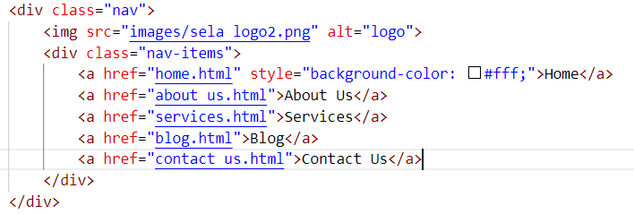

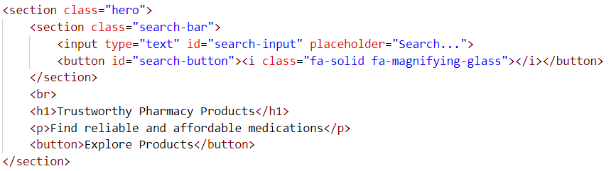

## **CSS CODE FOR HOME PAGE**





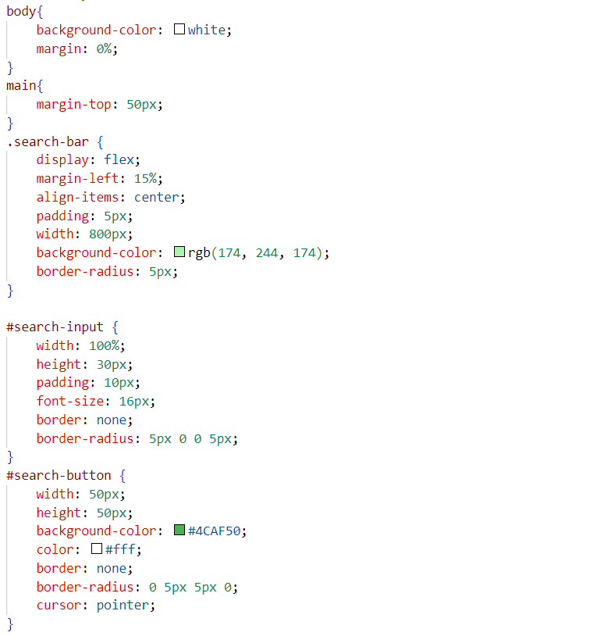

* **OUTPUT FOR HOME PAGE**
* **CODE FOR LOGIN PAGE:**

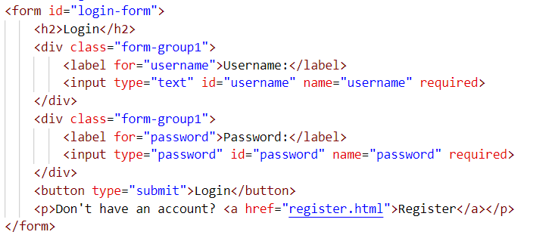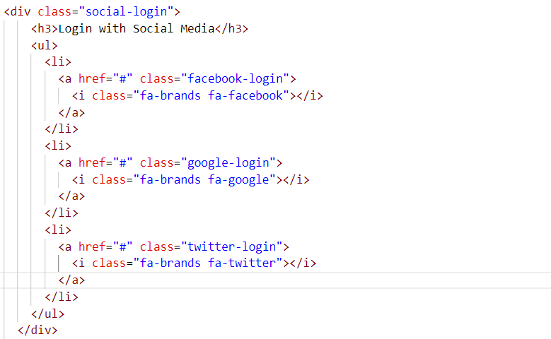

* **CSS FOR LOGIN PAGE:**

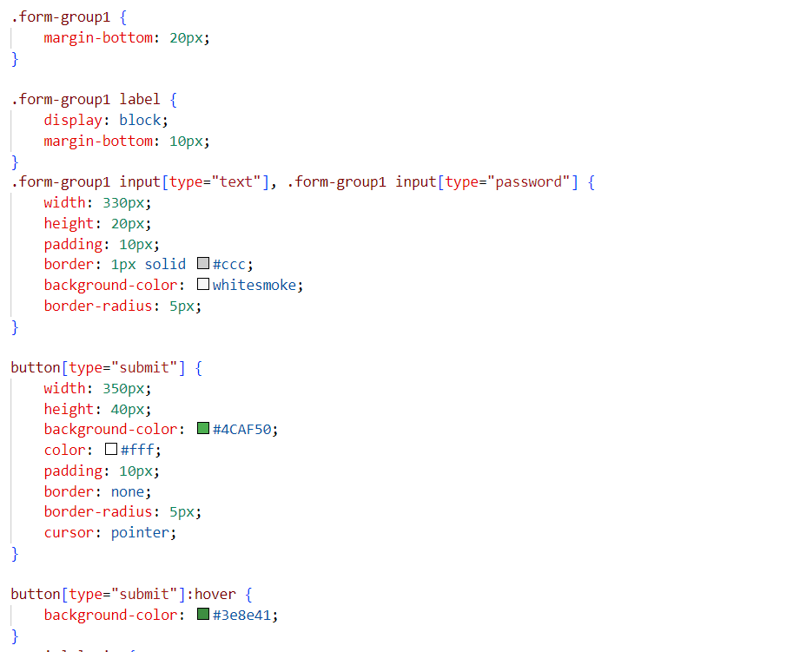

* **OUTPUT FOR LOGIN PAGE:**

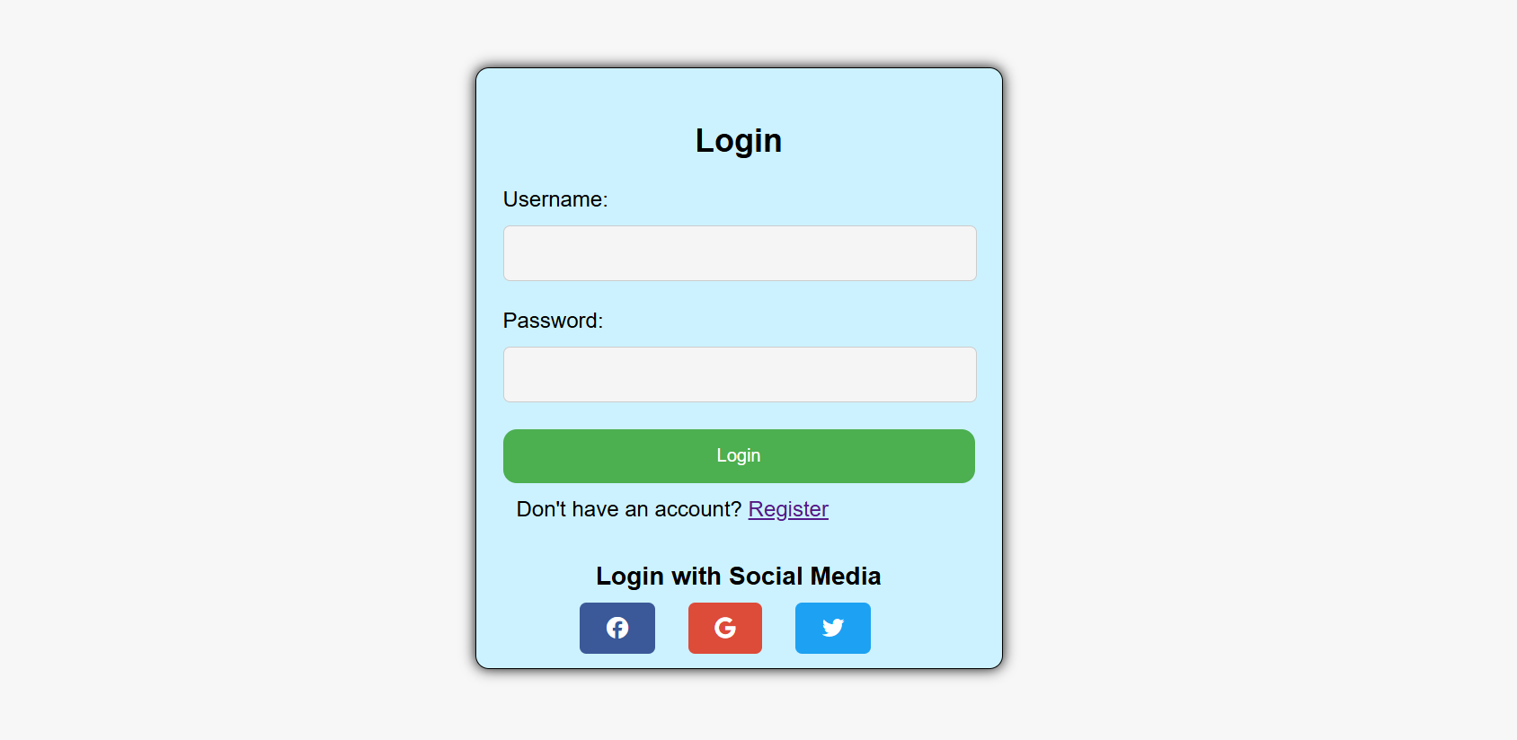

* **HTML CODE FOR ABOUT US:**

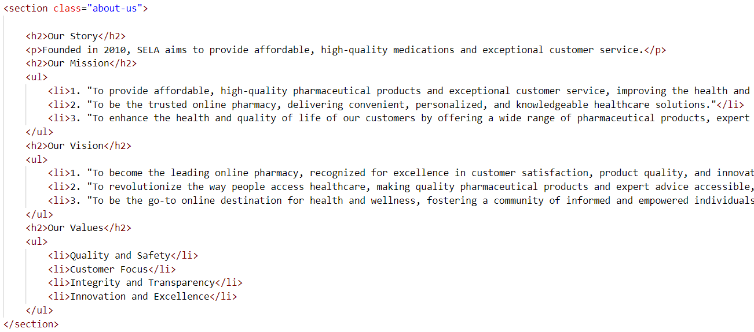

* **CSS CODE FOR ABOUT US:**

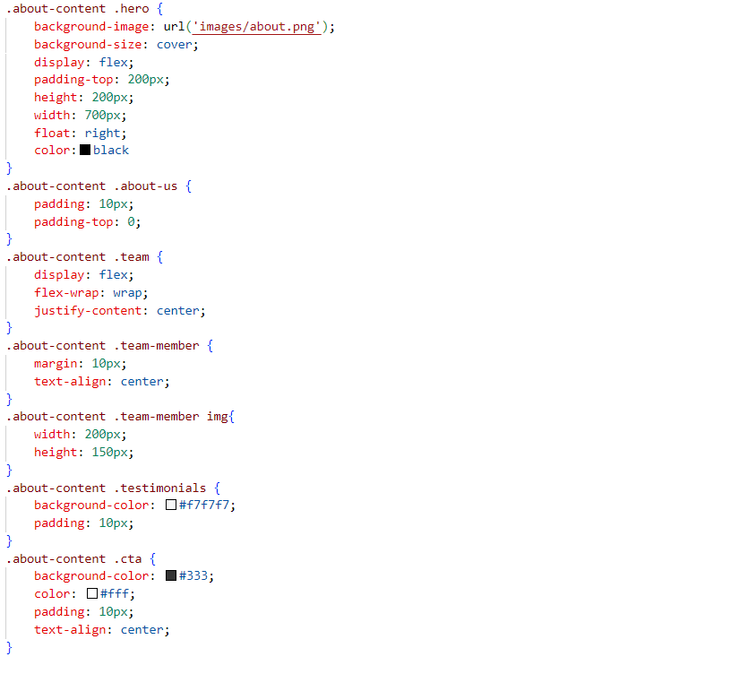

* 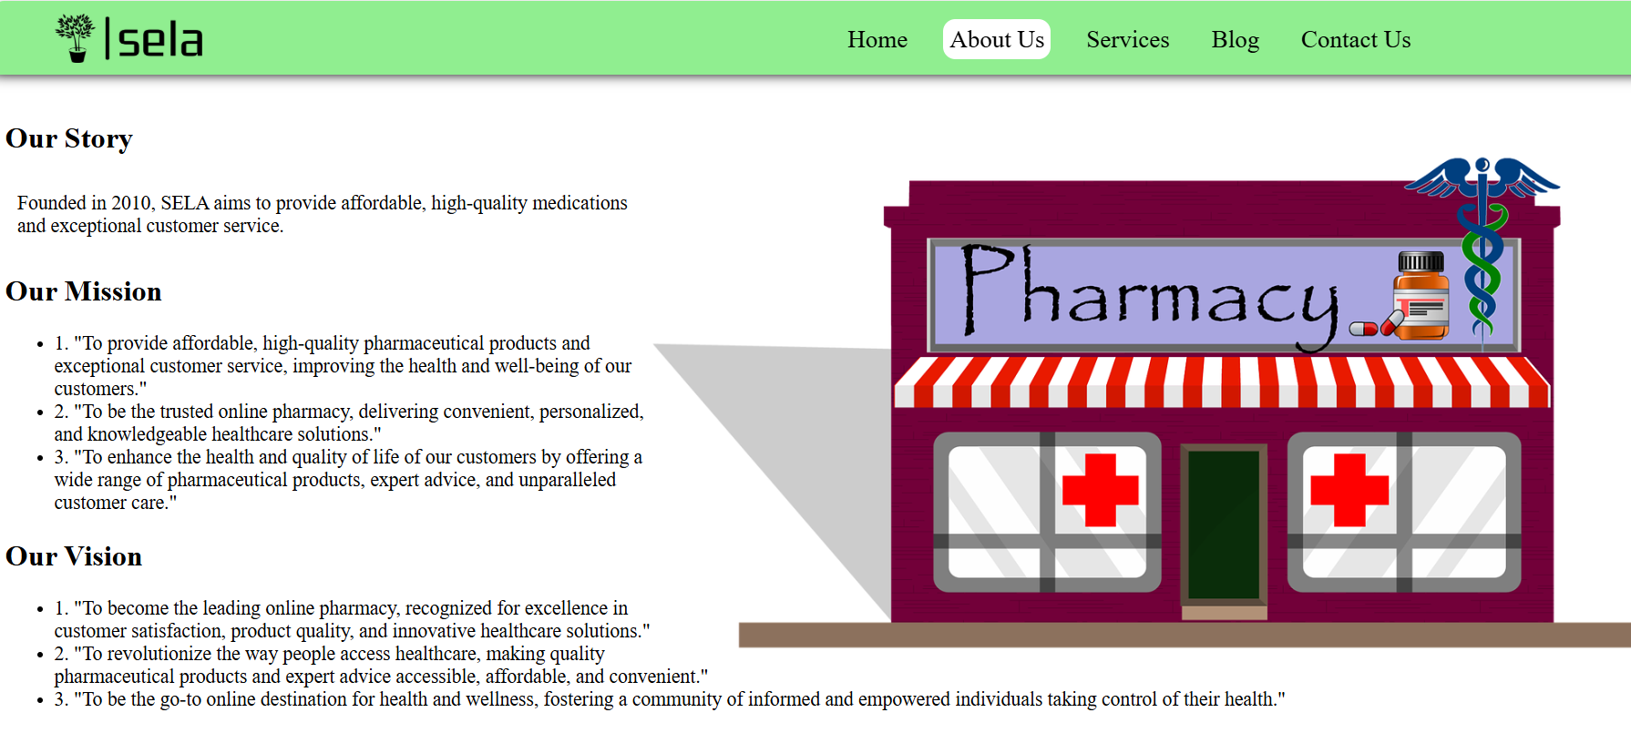**OUTPUT FOR ABOUT US:**
* **HTML CODE FOR SERVICES:**

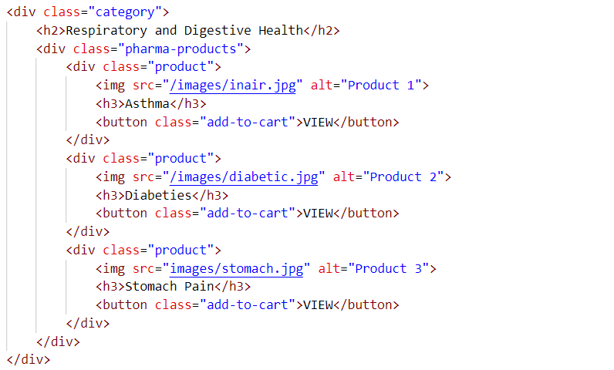

* **CSS CODE FOR SERVICES:**



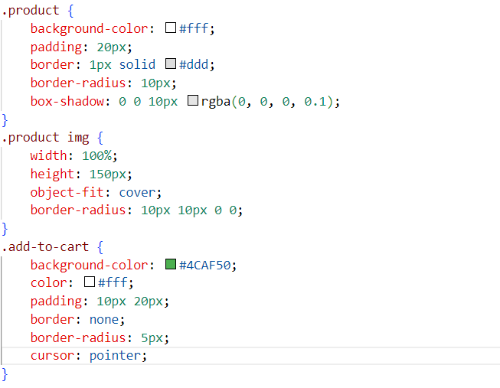

* **OUTPUT FOR SERVICES:**

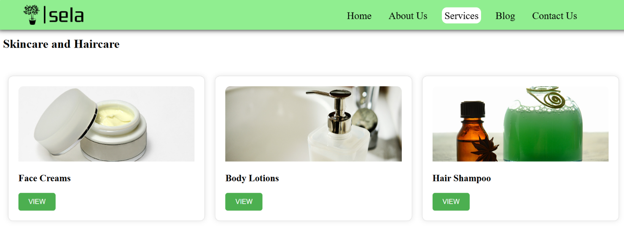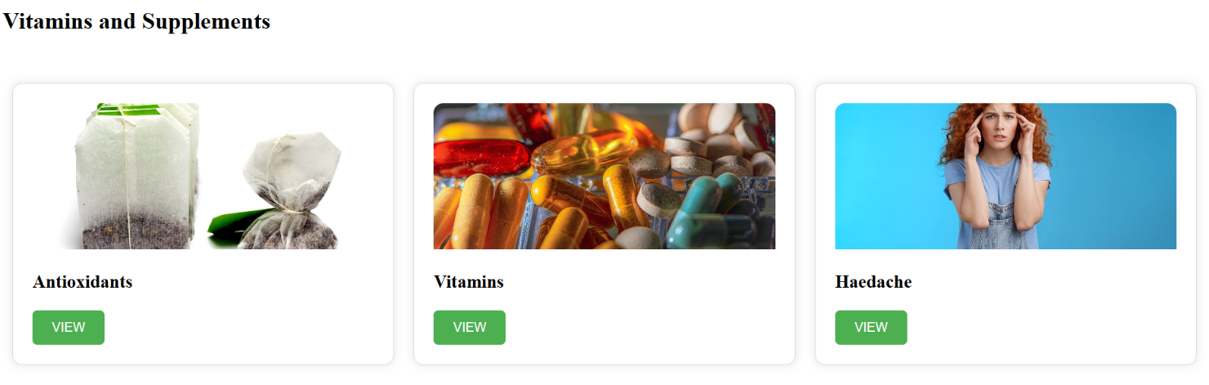

* 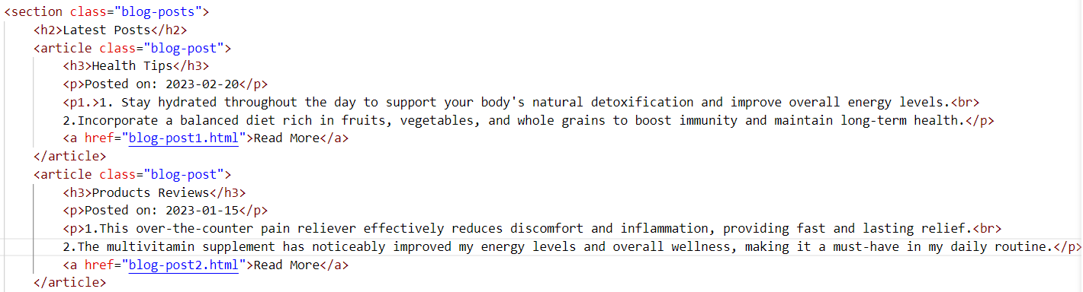**HTML CODE FOR BLOG PAGE:**



* **CSS CODE FOR BLOG PAGE:**

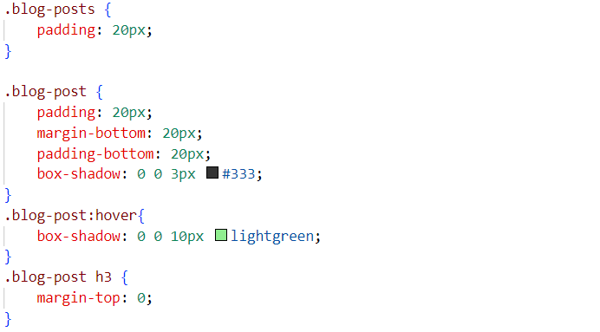

* 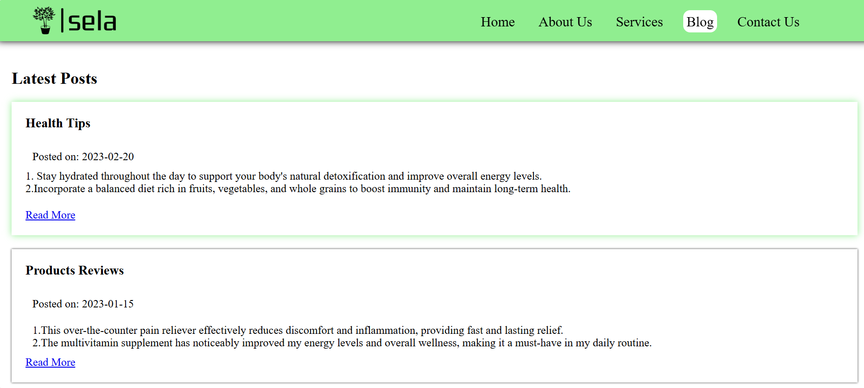**OUTPUT FOR BLOG PAGE:**
* **HTML CODE FOR CONTACT US PAGE:**

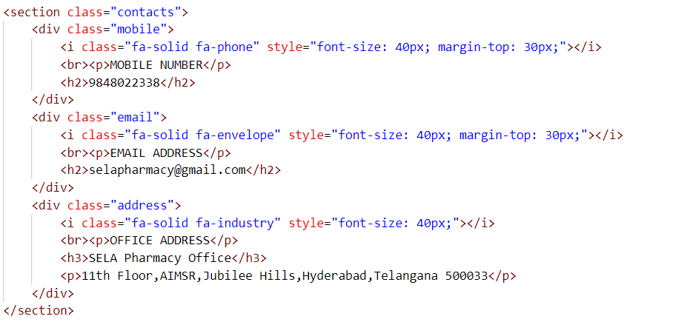

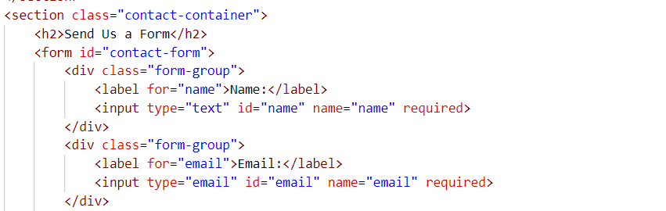

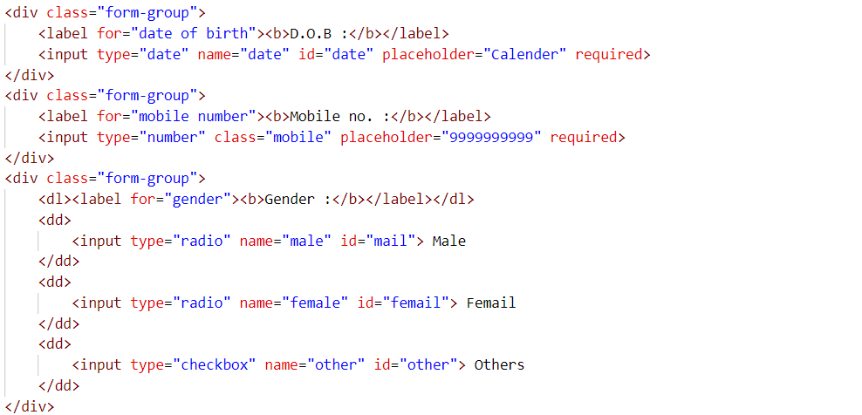



* **CSS CODE FOR CONTACT US PAGE:**

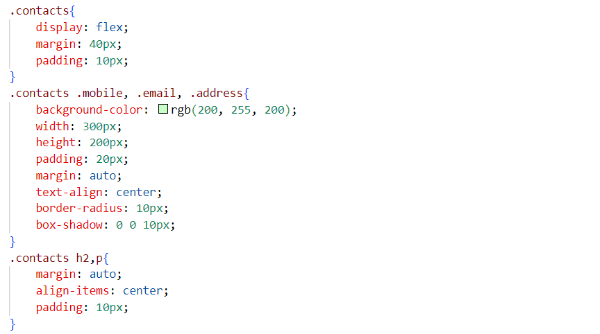

* 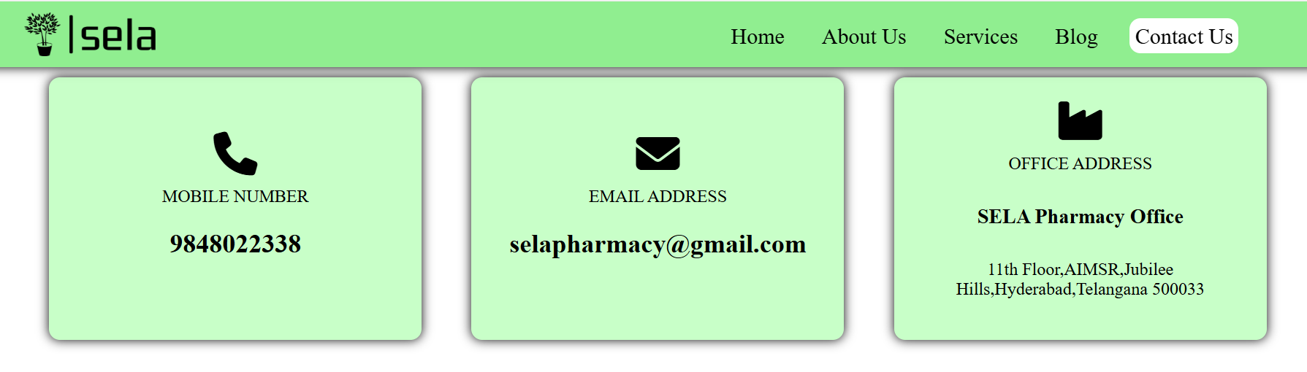**OUTPUT FOR CONTACT US PAGE:**

**CHAPTER 6: CONCLUSION**

In conclusion, the Pharma Products website is dedicated to providing high-quality health and wellness solutions tailored to meet the needs of our customers. With a comprehensive range of products, detailed resources, and a commitment to education, we strive to empower individuals to make informed health decisions. Our user-friendly platform ensures that finding and purchasing the right products is a seamless experience. We invite you to explore our offerings, take advantage of our informative resources, and join our community in prioritizing health and well-being.

pharmacy product websites provide a convenient, efficient, and secure platform for consumers to access a wide range of medications, healthcare products, and wellness services. By offering features like prescription management, home delivery, competitive pricing, and valuable health resources, these online platforms make it easier for individuals to manage their health needs from the comfort of their homes. The ability to compare products, read customer reviews, and consult with licensed pharmacists further enhances the customer experience. Overall, pharmacy websites play a crucial role in improving accessibility to medications and healthcare services, making healthcare more convenient and affordable for a broad audience.

Thank you for choosing us as your trusted partner in health.

**CHAPTER 7: REFERENCES, URL’S & PHOTOS**

**References:**

1. ChatGPT-4o: <https://chatgpt.com/share/672f068b-443c-8002-8cbd-df3c4b33b426>
2. Google: <https://www.geeksforgeeks.org/java-full-stack/>
3. You Tube: <https://youtu.be/rHs0b2MaNpg?si=kTVGI3VL5iqtfLNp>

**Url’s:**

Website Files and Document Contains Url:

<https://drive.google.com/drive/folders/1KA4fFbWYVN2WmpwOBAWFlp26-XukoFp5?usp=sharing>

**PHOTOS:**

**Photo-1:** Output for Home Page



**Photo-2:** Output for Login Page

**Photo-3:** Output for About Us Page

**Photo-4:** Output for Services Page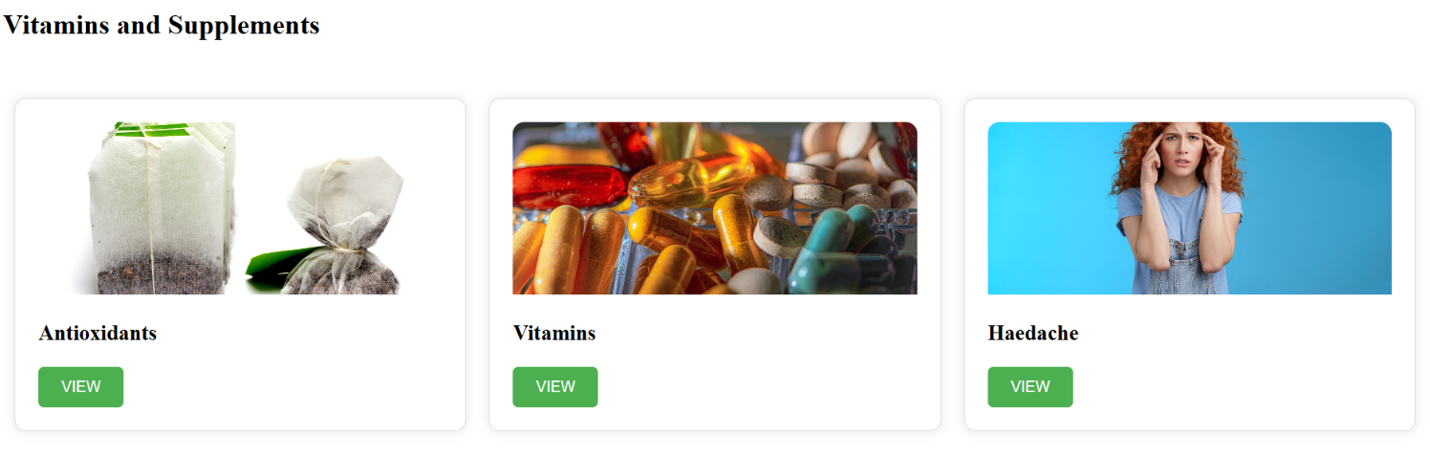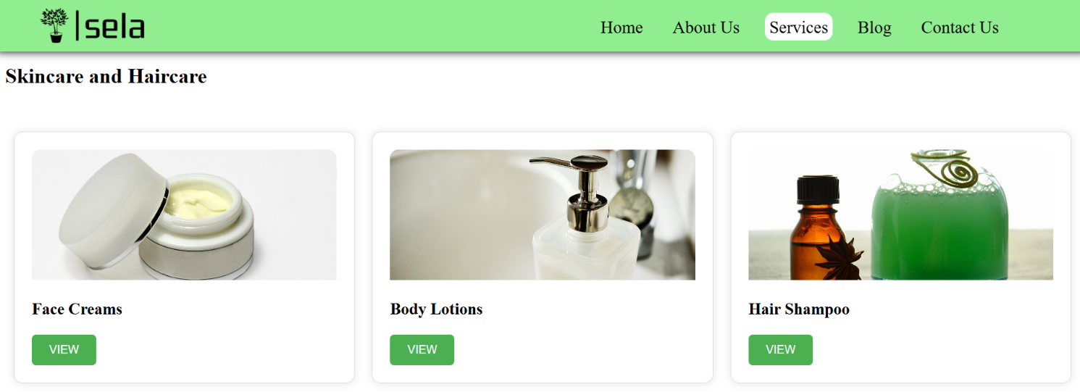

**Photo-5:** Output for Blog Page



**Photo-6:** Output for Contact Us Page